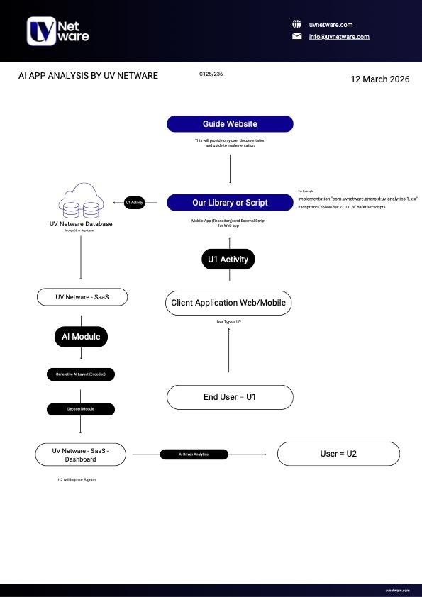

- Step I (U1 activity to Database)
- Creating a light JavaScript file for listening to events by U1
- Use FastAPI to receive these events
- Use MongoDB to receive the events from the API
- Step II (Firebase authentication)
- Step III (AI Module)
- Fetch the data of U1 activity for the U2 client from MongoDB
- Feed this data into an LLM (like ChatGPT, Gemini, or an agentic workflow) with a prompt to analyze the behaviour
- We force the LLM to output its analysis in a strict JSON format
- Backend takes the raw JSON file and translates it for UI
- Step IV (Data to U2)
- log in via firebase
- Based on the JSON, the frontend renders the charts and summaries

Dashboard
- Eraser.io type workflow to the client, showing how their data is being used
- Most visited link
- Link with the most time
- Link with the most clicks on the buy button
- Traffic time on the main website
- links with most view time
- Graphs (traffic time)
- Summary ( based on given data, recommendation given by LLM)
- Chatbot

